.

**Text Summarization API – Documentation**

(Text Summarization App with FastAPI & Gemini API)

1. **Project Overview**

This project impliment a **text summarization REST API** built with **FastAPI** . It integrates with uses **Google Gemini API** to generate concise summaries of user-provided input text.  
It is lightweight, easy to deploy, and comes with interactive API docs.

**Key Feature :**

* Summarizes text into a shorter version (configurable length).
* Exposes a REST API endpoint (/summarize) for requests.
* Uses prompt engineering to guide Gemini API output.
* Built on FastAPI for high performance & auto-generated Swagger docs.

1. **Technical Architecture**

**High-Level-Workflow:**

1. **Client** sends a POST request with text + desired summary length.
2. **FastAPI app** validates the request using Pydantic and constructs a prompt for Gemini API.FastAPI Backend receives request → builds prompt.
3. **Gemini API** (via REST) generates a summary and sends it back as JSON.
4. **FastAPI app** returns the summarized text to the client.Backend parses response → sends summary back to client.

Client -> FastAPI Backend  -> GeminiAPI

**Architecture Diagram:**  
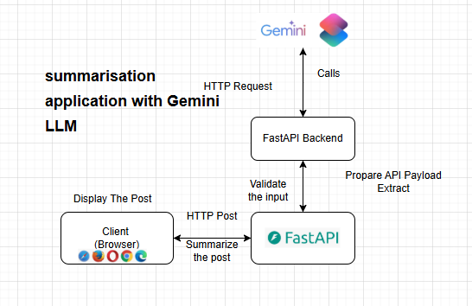

**3. Project Structure**

text-summarization-app/

│

├── app.py # Main FastAPI application

├── requirements.txt # Python dependencies

├── README.md # Documentation (this file)

└── .env (optional) # Store API Key securely (not checked into git)

**4. Installation**

1. **Clone the Repository**

git clone https://github.com/your-username/text-summarization-app.git

cd text-summarization-app

1. **Create Virtual Environment (Recommended)**

Create virtual env file named - venv

python -m venv venv

source venv/bin/activate # On Windows: venv\Scripts\activate

Activate venv  
  venv\Scripts\activate

1. **Install Dependencies**

Pip install -r requirements.txt

python -m pip install -r requirements.txt

1. **Start FastAPI server**

uvicorn app:app --reload

python -m uvicorn app:app --reload

Note - Any update in env file first deactivate and than activate

venv\Scripts\deactivate

**5. Environment Setup**

1. **Gemini API Key**  
   Sset Gemini your API key from Google AI Studio.
2. **Store Key Securely**  
   Create a .env file (optional but recommended):

GEMINI\_API\_KEY=your\_api\_key\_here

Then load it in app.py using os.getenv("GEMINI\_API\_KEY").

**6. API Specification**

**Endpoint -**

POST /summarize

**Request Body**

text (string, required) → The passage to summarize.

max\_tokens (integer, optional, default=15) → Approx. word count for summary.

**Response**

return {"summary": summary}

**7. Running the API**

Start the FastAPI app with Uvicorn:

uvicorn app:app --reload

API will run at:  
➡ **[http://127.0.0.1:8000](http://127.0.0.1:8000" \t "_new)**

Swagger UI available at:  
➡ **[http://127.0.0.1:8000/docs](http://127.0.0.1:8000/docs" \t "_new)**

1. **API Endpoint**

**POST /summarize-text**

**Request Body**

{

"text": "Machine learning is a field of AI that focuses on building systems that learn from data.",

"max\_tokens": 200

}

| **Field** | **Type** | **Required** | **Description** |
| --- | --- | --- | --- |
| text | str | ✅ | Text you want summarized |
| max\_tokens | int | ❌ | Maximum output length (default = 300) |

**Response Example**

{

"summary": "Machine learning is a branch of AI that creates systems capable of learning from data."

}

**Testing with cURL**

curl -X POST "http://127.0.0.1:8000/summarize-text" \

-H "Content-Type: application/json" \

-d '{"text": "Deep learning uses neural networks to learn patterns from data.", "max\_tokens": 100}'

**Dependencies**

* **FastAPI** – Web framework for API
* **Uvicorn** – ASGI server
* **Pydantic** – Data validation
* **Requests** – To call Gemini API

requirements.txt example:

fastapi

uvicorn

pydantic

requests

python-dotenv

**Error Handling**

| **Error Code** | **Cause** | **Example Response** |
| --- | --- | --- |
| 400 | Invalid request body | {"detail": "text field is required"} |
| 500 | Gemini API error | {"error": "Failed to generate summary"} |